Title of Blog: #BUILDINGRESILIENCE

Resilience – the act of handling life and overcoming its challenges.

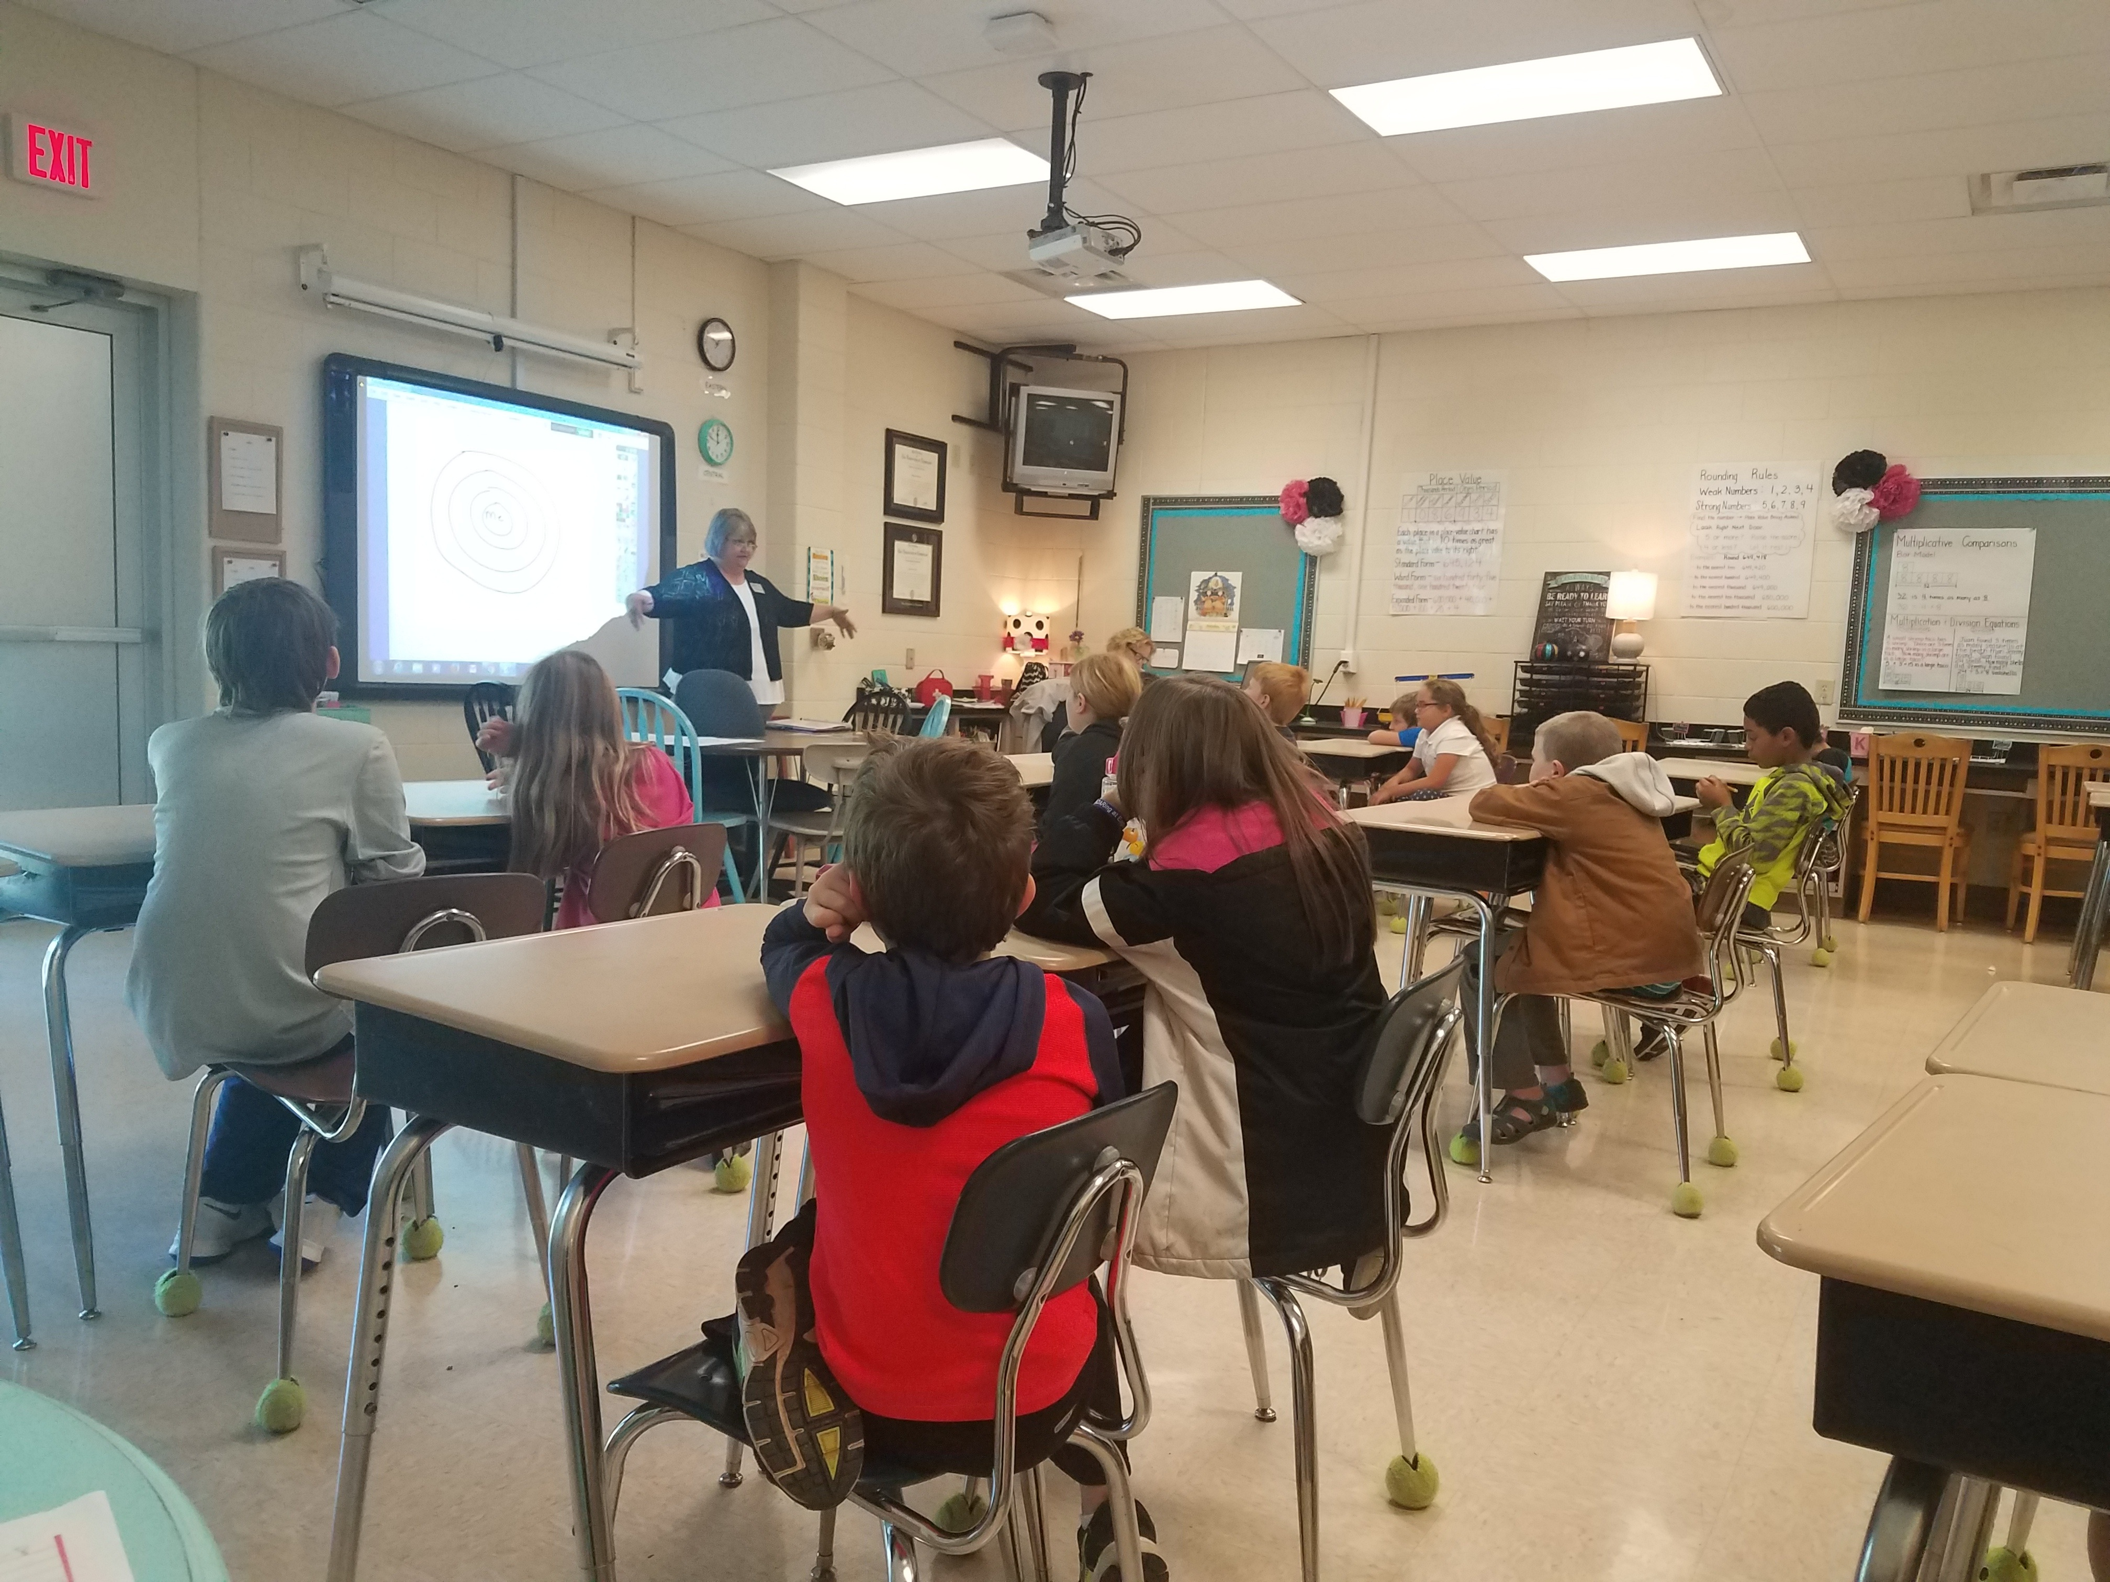

In elementary, middle and high school we were taught a lot of things: mathematics, history, science etc. Most of us were even taught about finances and how to balance a checkbook. But are these subjects really all youth needs to succeed in their everyday life and overcome their challenges?

Can the Pythagorean Theory help a child with the stress they experience when they have a disagreement with their sibling? Would the process of photosynthesis help a child if they were being bullied? What about the American Revolution? Would that help a child face the domestic violence that is going on within their home?

I think most would agree that the Pythagorean Theory, photosynthesis and American Revolution all have their place in valuable education, however they’re not practical for day-to-day adversity that a child may face. All youth experience challenges, no matter how big or small. This in turn causes the stress that results from those challenges to impact the youth’s development neurologically due to their brains rapid development. So why isn’t their an emphasis on learning skills to overcome these challenges?

At COMPASSion Counseling, we were able to recognize this societal dilemma, thus causing us to take action in schools within our counties. Thus far, we have gone into a high school and two elementary schools to implement our six-week resilience program. Throughout the program, the youth are taught skills such as self-relaxation techniques, coping mechanisms, practicing pro-active responses, optimism, positive self-talk, respecting others personal space, how to be a team player and how to utilize problem solving skills.

The amount of information that these students have retained is nothing short of amazing and their participation has been outstanding. At COMPASSion Counseling, we are confident that the skills taught within this program will have some sort of impact on our youth’s life. We know that there is only so much that we can do, but it counts even if we just help make their everyday stressors just a little more bearable.

We are more than halfway through with our six-week program at our current elementary school and are hoping to implement the program in another school this coming spring. We look forward to continuing this program, witnessing the success of our youth and striving to make an impact no matter how big or small.

“Fall down seven times, stand up eight.”

